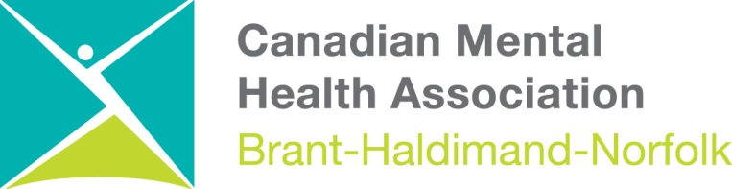

CMHA Brant-Haldimand-Norfolk Branch
Slate of Officers, 2021-2022
Mark Solomon, Board President
Kevin McGilly, Vice President
Franciss Dykstra, Secretary
Eric Harrop, Treasurer
Katheleen Ellis, Board Member
Alfred Spencer, Board Member
Jennifer Bard, Board Member
Dana Maddock, Board Member
Joseph Persia, Board Member
Lynn Dale, Board Member
Stephanie Dinsmore, Board Member
Tracy Woodford, Board Member
Alex Morris, Board Member
Michael Benin, Ex-Officio *

